**A Python Project Report on Real Estate Data Analysis and Price Prediction Tool:**

INTRODUCTION:-

In the ever-evolving real estate landscape, informed decision-making is crucial. The Real Estate Data Analysis and Price Prediction Tool is a comprehensive solution designed to empower stakeholders in the real estate domain with valuable insights and predictive analytics. This Python-based tool combines data analysis, machine learning, and a user-friendly interface to provide users with a reliable means of understanding market trends and predicting property prices.

OBJECTIVES OF THE PROJECT:-

1. Property Search based on location ,property type like 1 BHK, 2 BHK, etc.

2. Price Prediction ML model based on historical data, location, property features, and market trends.

3. Property analytics and visualization tools in the form of graphs.

4. Loan calculator for people who want a loan.

ABOUT THE PROJECT:-

In this Python Project, I used various Python modules in an attempt to make a comprehensive Real Estate Data Analysis and Price Prediction Tool. The modules used include Tkinter, Pandas, Matplotlib, Pillow, Sklearn, and Numpy. In this project, the user first loads the data in the form of an Excel sheet(in a particular format), once he loads the data, a graph pops up displaying the average price per sqfoot vs year considering all the places present in the excel sheet, in the next step the user selects a place where he wants the analysis and prediction to be done from the dropdown menu which will be displayed, once the user selects the place, in the next step the user will select the type of property he or she is searching for, like 2BHK,3BHK or 4BHK.In the next step, the user presses the Calculate Price Range button, by pressing this the Price Range will be displayed and a graph for that place will also be displayed, for simplicity in calculating the loan component I have considered the property price to be the average of the Price Range. In the next step, the user is given an option called “Want a Loan?” Then, when pressed a new window pops up confirming whether the user wants the loan or not, if the user selects yes then a new window pops up where the user fills two fields, they are, How much amount of the loan the user wants (in percentage of property price), and the tenure. Based on this a new window pops up displaying the amount of interest rate he will be paying and the EMI he will be paying to repay the loan amount. I have also made another price prediction model which the user can use to predict the price per sqft of a particular place before investing his or her money.This model uses the historical data of the price which is given through an Excel sheet.

MODULES USED:-

1)Tkinter

2)Pandas

3)Matplotlib

4)Pillow

5)Sklearn

6)Numpy

INPUT HANDLING:-

The program accepts the data through an Excel sheet(in a particular format).

OUTPUT DISPLAY:-

Output is displayed in various forms like buttons, graphs, windows, etc.

RESULTS AND OUTPUTS:-

The program starts with this window,

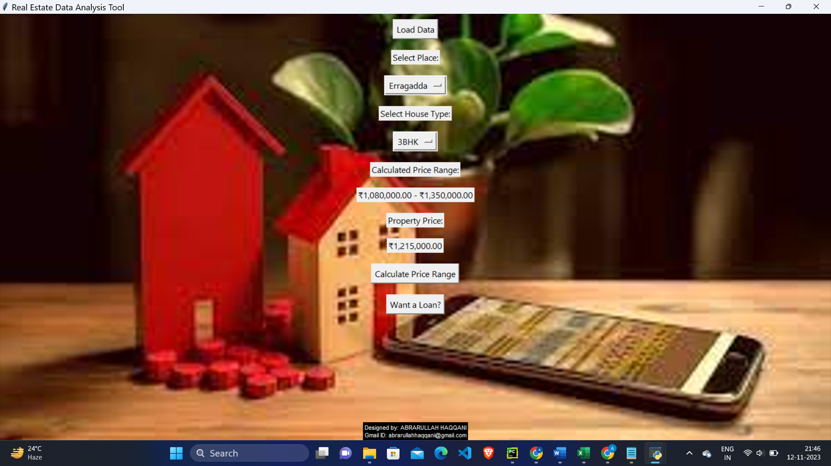

When load data is pressed and the Excel sheet is loaded, then a graph is displayed like this,

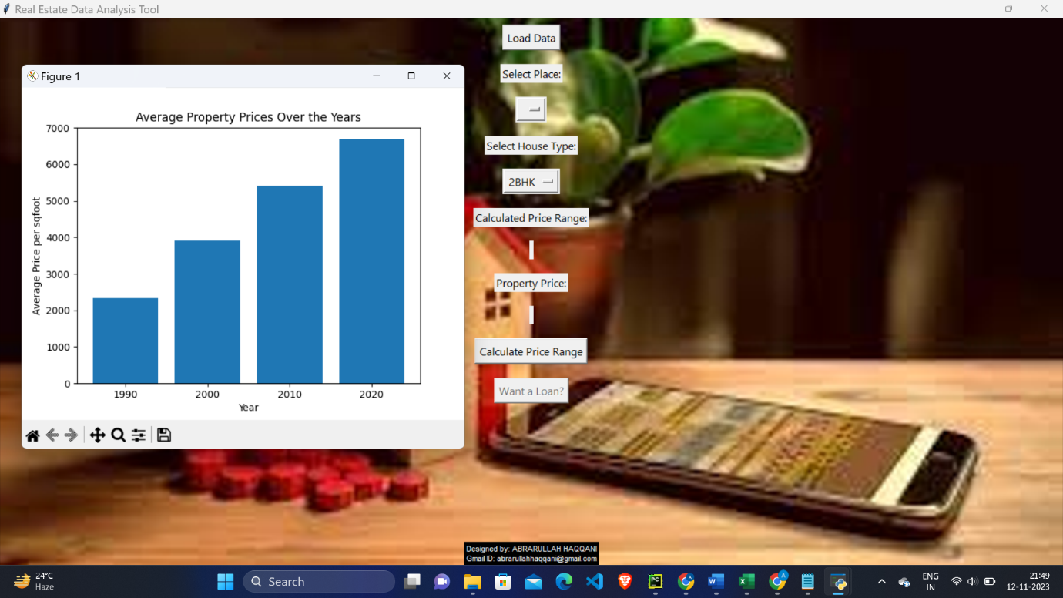

When the user selects the place from the dropdown menu, it appears like this,

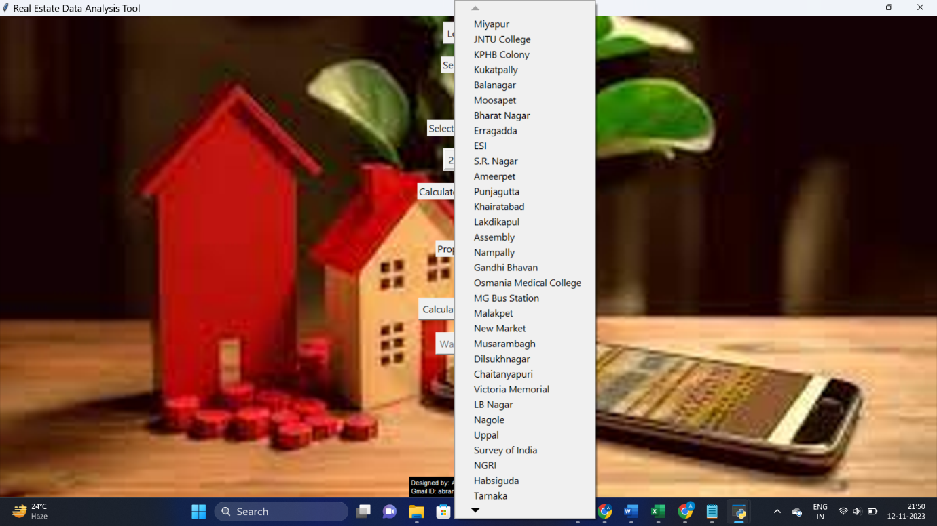

After this user selects the type of house,

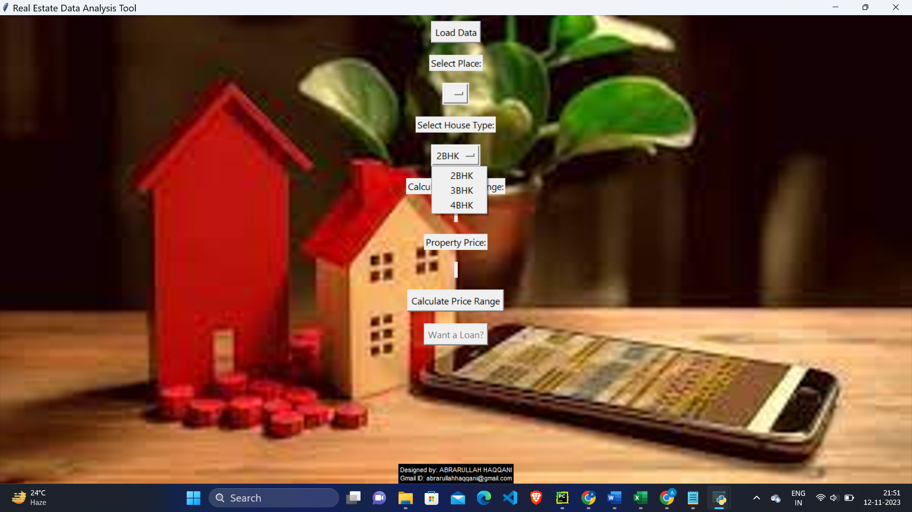

After this, the user presses the Calculate Price Range button the range for a particular place looks like this,

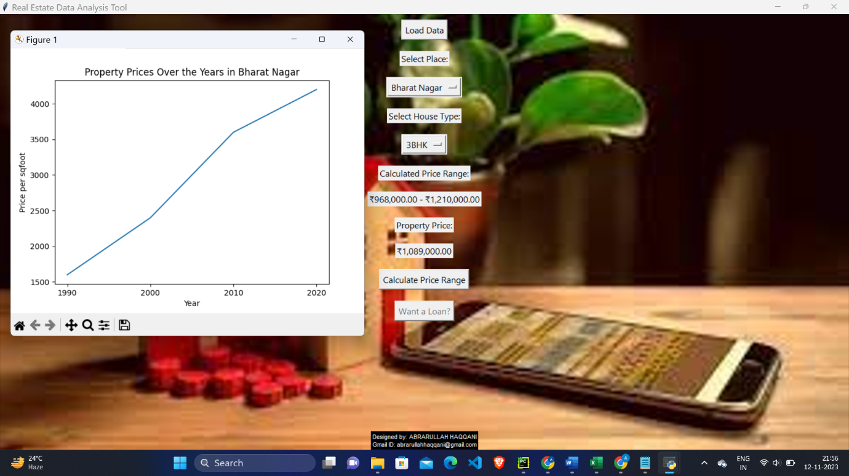

After this user presses want a loan option, it looks like this,

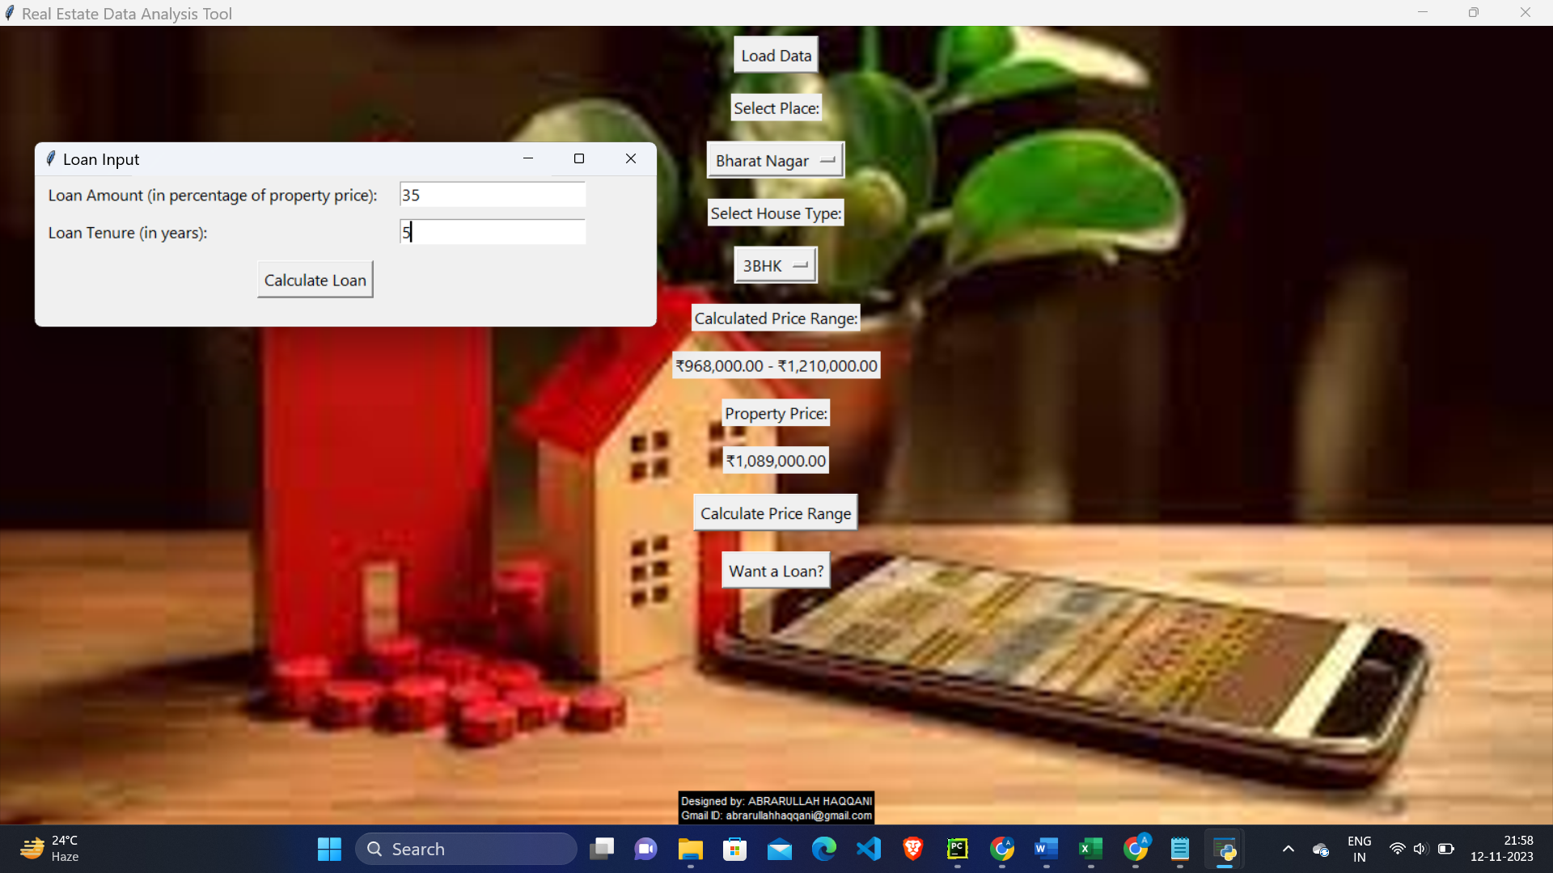

Once those fields are entered, we get,

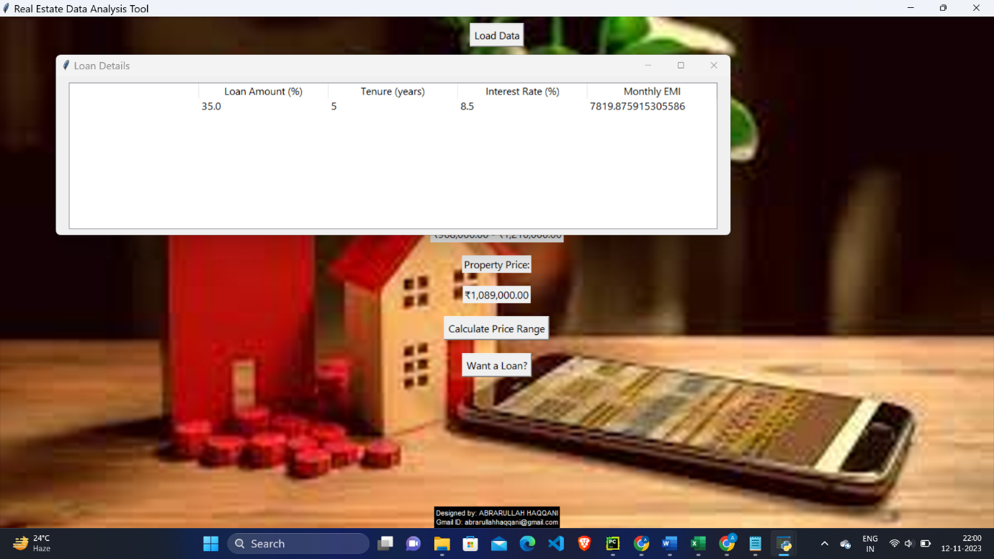

I made another price prediction model which looks like this,

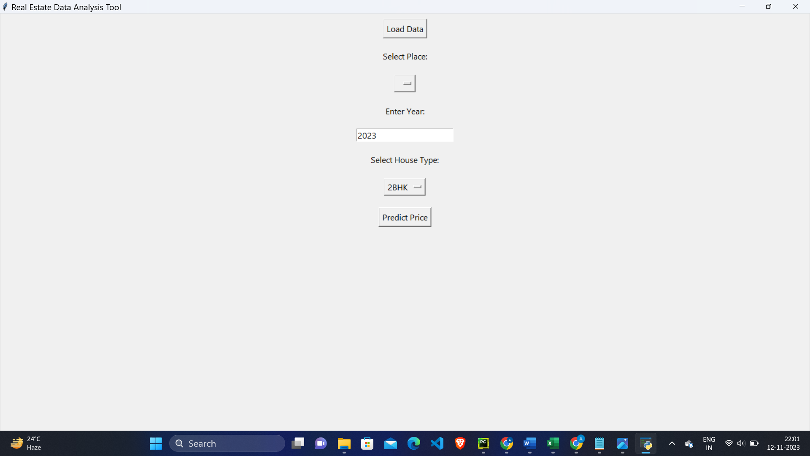

Here as above once we select a place, year and house type and press predict price the program displays predicted price based on the historical data.

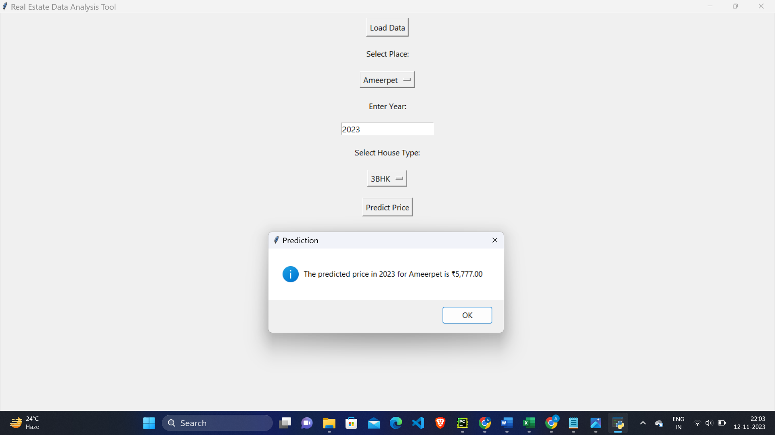

This wraps up the project.

POTENTIAL IMPROVEMENTS:-

1)I think the data set that I used tries to cover most of the places in Hyderabad, but I believe this project will have a lot of potential and worth once the dataset has places covering at least the entire India.

2)For simplicity I had to assume that the property price is the average of the calculated price range, I think this can also be improved.

3)For efficient data storage, other databases such as SQL or MongoDB can be used.

4)User interface can be further developed to enhance the interaction with users.

CONCLUSION:-

In conclusion, the Real Estate Data Analysis and Price Prediction Tool stands as a testament to the intersection of advanced analytics and real-world decision-making in the dynamic field of real estate. Through the integration of Python programming, machine learning, and an intuitive user interface, this project addresses the critical need for insightful and predictive tools in the real estate market.